Few Tutorials -- Expalins the concepts and best practicies

Developing – Restful API for social media...

Social Media Restful API’s using JAX RS

Webservices
Services exposed to internet for programmatic access
Diff pecies of code in different places
How can we post the applciaiton by posting on to the wall
Publish webservices and post things on facebook and twitter have provided

API.twitter.com Developers use.

Webservices Type

Rest Web services
SOAP web services

WEB --> HTTP

Client --> Sends Request -- > Server
Server --> Sends Response -- > Client

Protocol.
Client --> Server
MESAGE FORMAT and SOAP protocol used by soap web services

Client <-- --> Server

HTTP diff methods are avaialble

Method need to be used
GET/PUT/DELETE/POST

Service definition for SOAP is WSDL this document is made available to all the clients.

REST AND HTTP

HTTP ( Hyper Text Transfer Protocol)
Hyper Text is used to transfer data.
Contains logical link to other text
and The links are called as hyperlinks

Resource Locations:

HTTP Methods : GET / PUT/POST/DELETE

MetaData:

200 – Success
500 – Server error
404 - Error code

Message Headers contains the content type
Follwoinga re the content types they are

text/xml,
application/json

Content Negotiation:

Resource URI’s

App is called as Messenger
Lets
- Post Messages
- Comment Messages

Design :

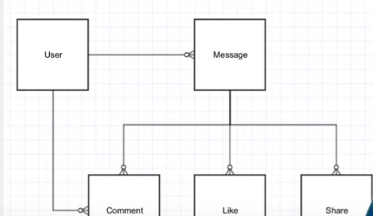

Web Application URI’s

Get a message /getMessages.do?id=10

or

/retrieveMEssages.action?id=10

When writing a REST api’s the consumers should have an URI

Common URI convetion for diff API’s are written

Resouce Based URI

/profiles/{profileName}

/messages/{messageId}

/message/1 gives message ID 1

The URI’s give resources....

Resource Releations

/messages/1/comments/1
/messages/1/comments/2

Generic URI will be

/messages/{messageId}/comments/{commentId}

/messages/{messageId}/likes/{likeId}
/messages/{messageId}/shares/{shareId}

Collection URI’s

/messages/{messageId}/comments these are all collection URI’s

Filetring

/messages?offset=30&li1it=30

/message?year=2014 and can use pagenation

Two Types

instance and colleciton URI’s

HTTP Methods

Crud status code

